International Shooting Competition – **‘Polish Open KALIBER 2024’**

from **27th** Nov. to **2nd** Dec. **2024**, Bialystok, Poland



***INVITATION***

**Dear Friends,**

We are honored to invite you to participate in the **XXV Jubilee edition** of the ***International Shooting Competition ‘Polish Open KALIBER’,*** *which will be held from*27**th** November – 2nd December 2024 in Bialystok, Poland. The Competition will take place at the Sports Hall (main hall – 40 SIUS positions, final hall with 20 SIUS positions).

**GENERAL INFORMATION**

* **Two individual starts (one with Olympic final – 2nd start),**
* **Mix Team events (separately Junior and Adults)**
* **Possibility to win the main prize in the Super Final – a Car\***
* **FRIDAY - EXTRA cash bonus for a high series (106,0+ Rifle, 99+ Pistol) from 50 up to 4700 Euro**

**Series 1-6 in a raw** 50+150+300+600+1200+2400 = **4700 Euro,**

**For single high series** 50 Euro each (example: 1st and 3rd = 50 + 50 = 100 Euro)

***Shooting events in categories:***

10 m **Air Pistol 60** Women / Women Junior, Men / Men Junior

10 m **Air Rifle 60** Women / Women Junior, Men / Men Junior

10 m **MIX Team** (Rifle, Pistol) **(separately Junior and Adults)**

**PRELIMINARY PROGRAMME:**

Wednesday, 27 Nov. – Arrivals

Thursday, 28 Nov. – MIX Team, accreditation

Friday, 29 Nov. – 1st Individual start - Elimination for the SUPER FINAL

Saturday, 30 Nov. – 2nd Individual start, **SUPER FINAL**

Sunday, 1 Nov. – 2nd Individual start, **Finals** from starts in Saturday and Sunday.

Monday, 2 Nov. – Departures

**ENTRY FEE:**

**100**€ per shooter (for two Individual starts), **25**€ per shooter (for MIX Event)**, 30**€ coach accreditations

**ACCOMODATION – the official Hotel:**

\*\***Hotel Turkus**

42 Euro per person - single room (with breakfast)

33 Euro per person - double and triple room

10 Euro - dinner

**DEADLINES /REGISTRATION (e-mail:** [**kaliberopen@gmail.com**](mailto:kaliberopen@gmail.com)**)**

Final Entry Form and Hotel Reservation must be send before **27th October 2023.**

**CORRECTIONS free of charge** until November 13, 2024 (acceptance of corrections depending on the number of free places). After this date, each change in the application - 25 Euro

**LATE ENTRY:** until November 18, 2023 (acceptance of the application depending on the number of free places) - double entry fee

**PRIZES:**

* The first place in the **Super Final – (a CAR or optional 8000 Euro)\***

*10% Tax should be paid by the winner.

* The second place in the **Super Final – 1999 PLN (**tax-free)
* **Prizes** for all competitors who entered to the **Super Final**
* **MIX Team** 1st place – prizes, 1st- 3rd places: medals, diplomas
* **Individual** **2nd start** - 1st place - prizes, 1st-3rd places: medals, diplomas
* **Small gifts - Lottery** after each finals

**EXTRA -** All competitors have a possibility to get to the extra event with cash prizes. There will be an opportunity to match and buy pellets of German **H&N**, Czech **JSB** organized by **INCORSA** and **ANSCHUTZ** Service.

**ORGANIZER:**

**Kaliber Białystok** **Sports Club**, Grunwaldzka Street 18, 15-893 Białystok, +48 889 889 985  
website: [WWW.KALIBERBIALYSTOK.PL](http://www.kaliberbialystok.pl)

**Shooting range and competition office:**

Sports Hall located in the school: „Zespół Szkół Rolniczych”

ul. Ks. St. Suchowolca 26, 15-566 Białystok, POLAND

GPS: 53.11, 23.202 **53°06'36"N 23°12'07"E,**

**Google maps:** „Zespół Szkół Rolniczych, Księdza Stanisława Suchowolca, Białystok”

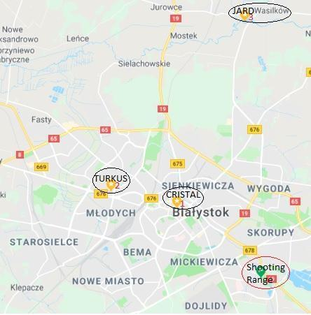

| *Monika Sobolewska +48 512 271 332 - ENG* | *Włodzimierz Aleksiejuk +48 502 649 400 - RUS* |
| --- | --- |
| *Competition Manager* | *President of Organising Committee* |